1.Task-Create user with name Techie and provide sudo access to user.

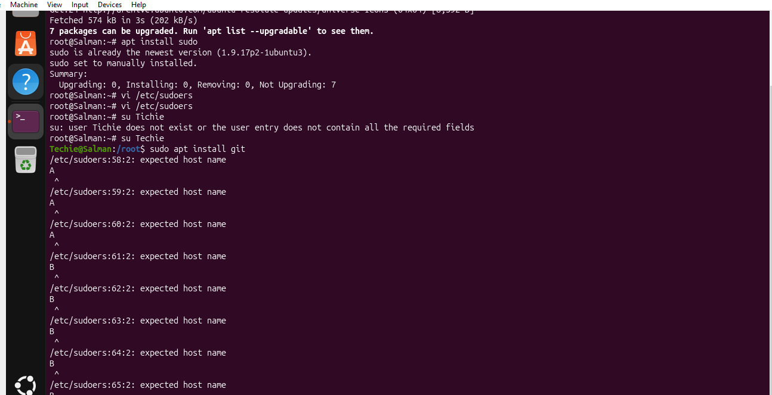

2.Task-Navigate to the home directory.


3.Task-Create a new directory.

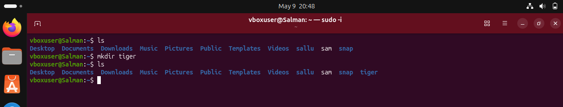

4.Task-List the contents of a directory.

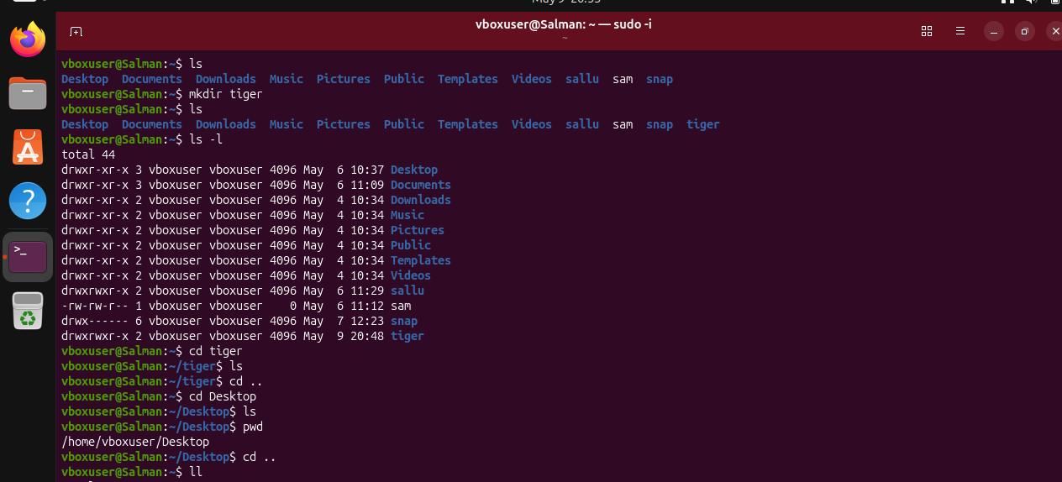

5.Change the current directory.

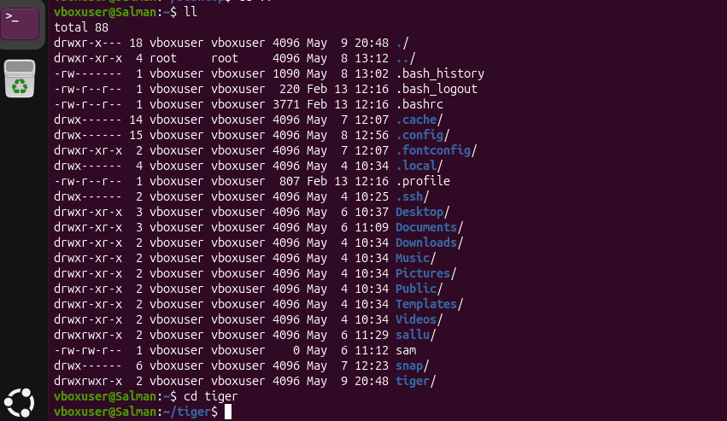

6.Task-Create a new empty file

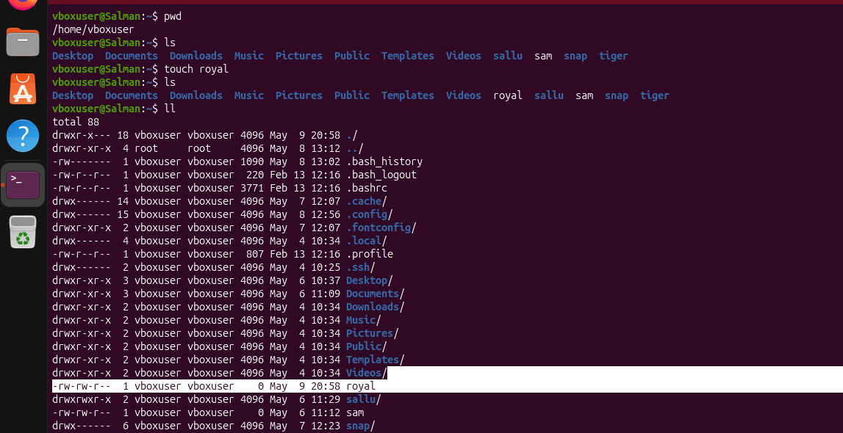

7.TaskView the contents of a file.

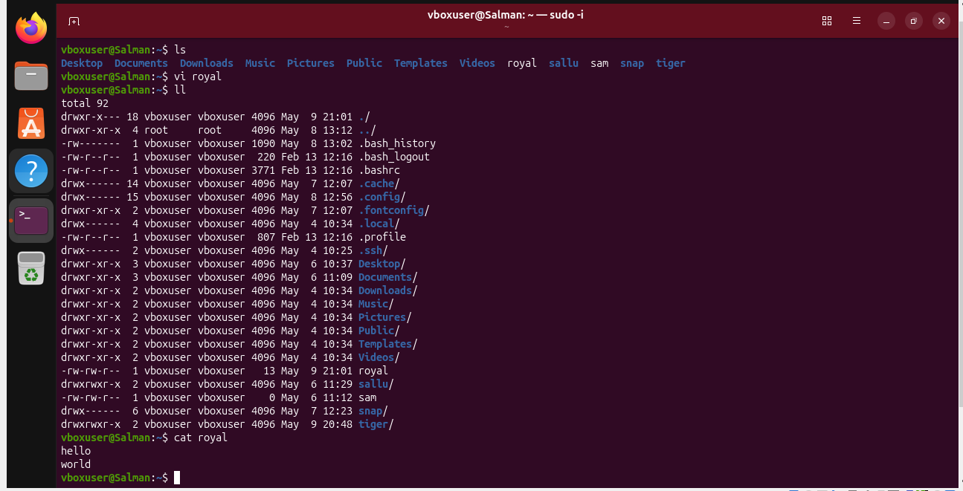

8.Task-Copy a file to another location

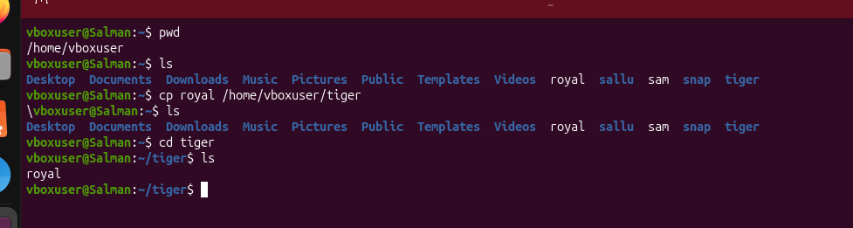

9.Task-Move a file to another location

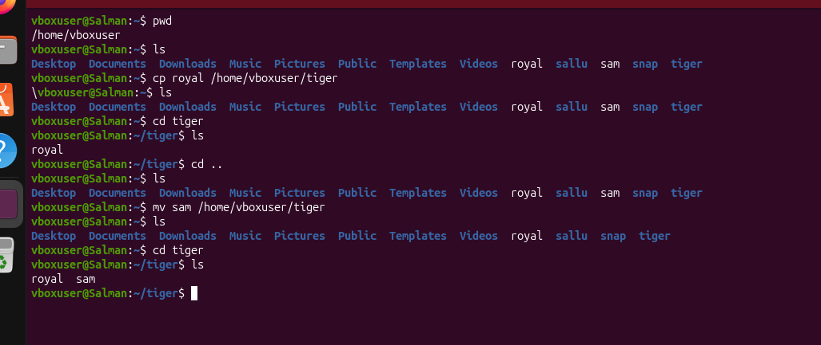

10.Task-Rename a file

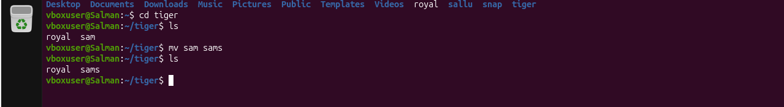

11.Task-Delete a file


12.Task-Grant or revoke permissions on a file or directory

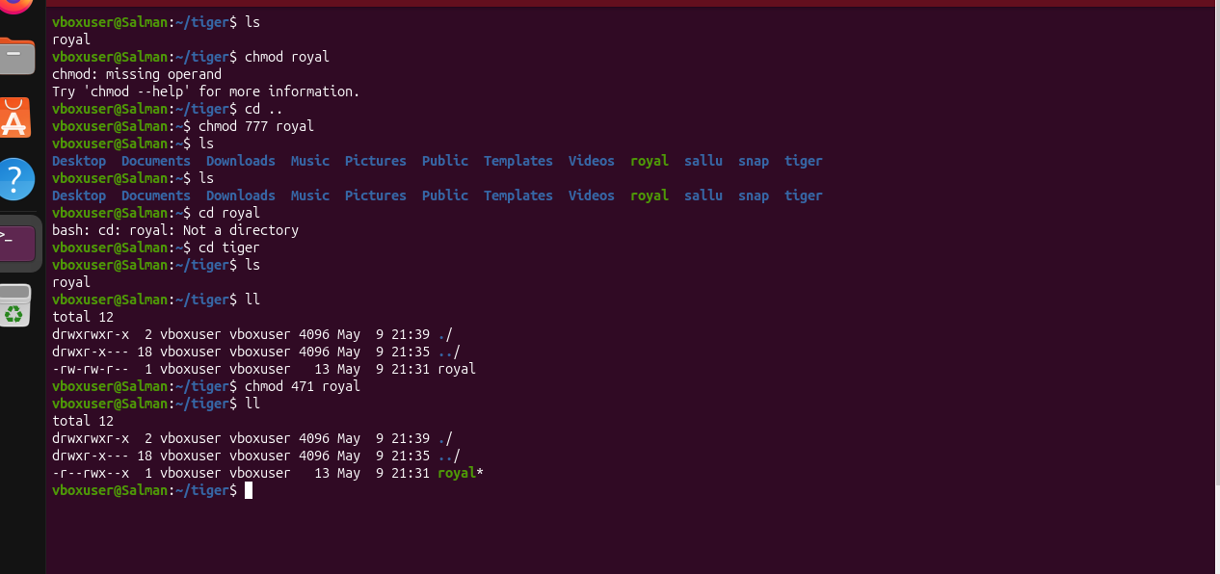

13.Task-View the current date and tie

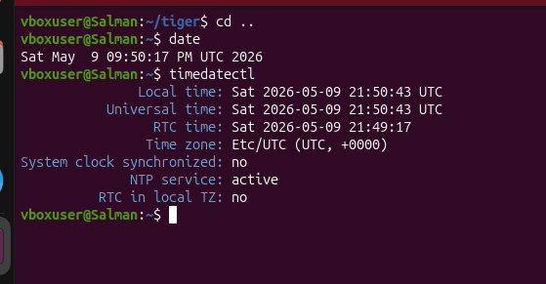
14.Task-Check the system uptime

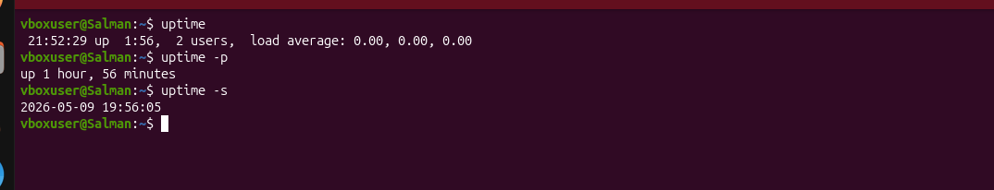

15.Task-View the running processes
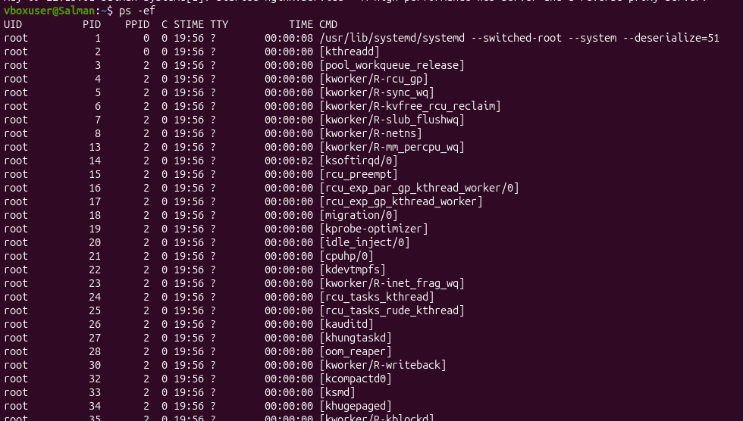

16.Task-Kill a running process
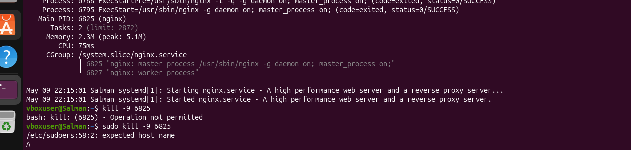

17.Task-Install a package using the package manager (e.g., apt or yum)
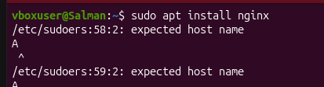

18.Task-Update the system packages

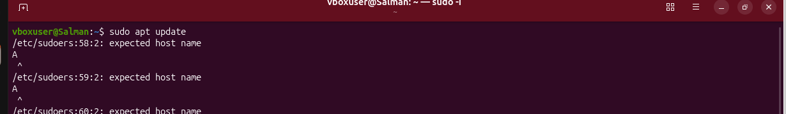

19.Task-Create a symbolic link
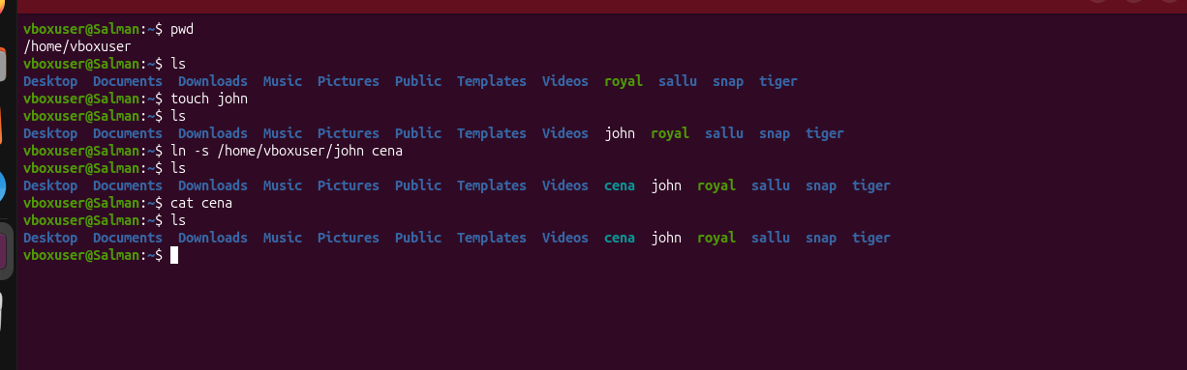

20.Task-Search for files using the find command
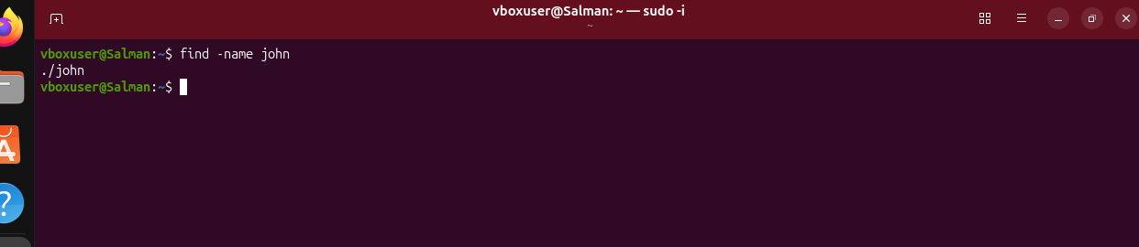

21.Task-Compress and decompress files using tar

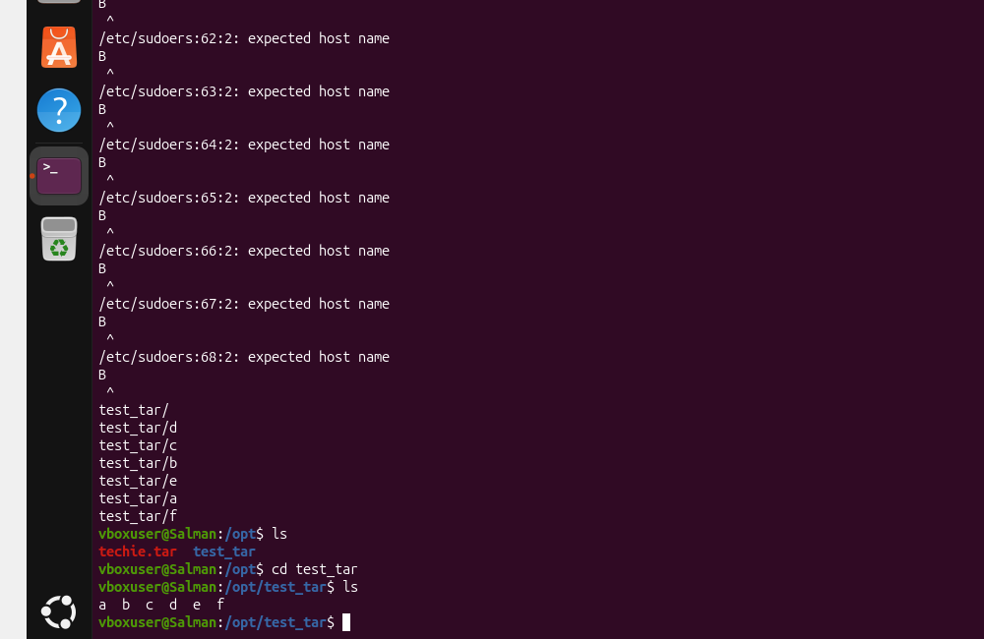

22.Task-Monitor system resources with top or htop
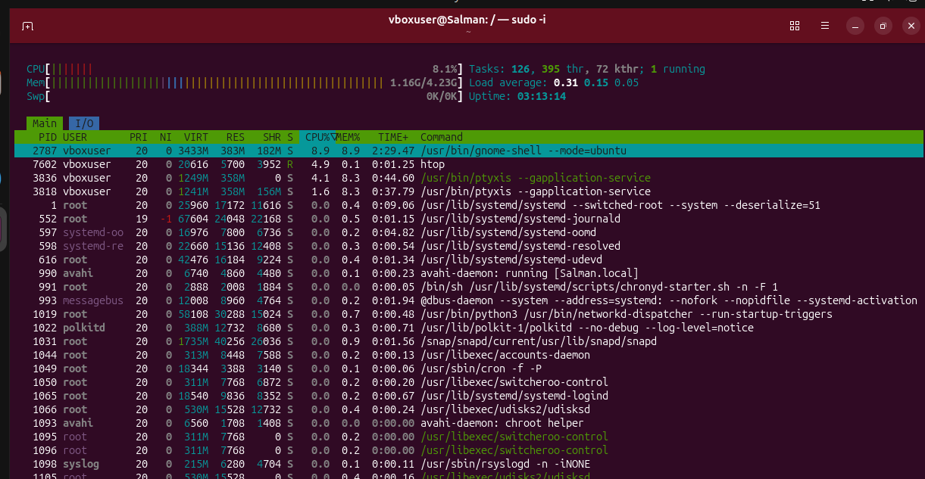

23.Task-Create and manage user groups
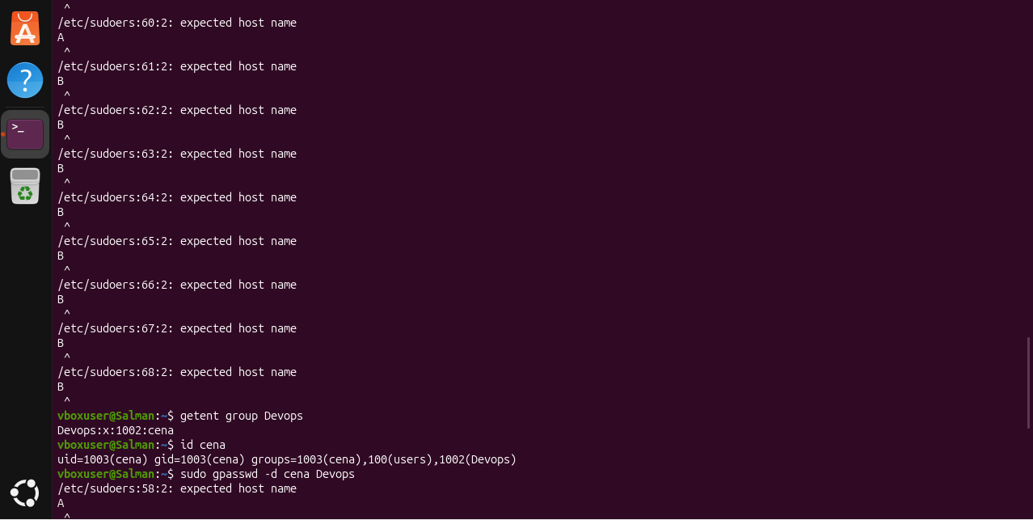

24.Task-Set up SSH password less authentication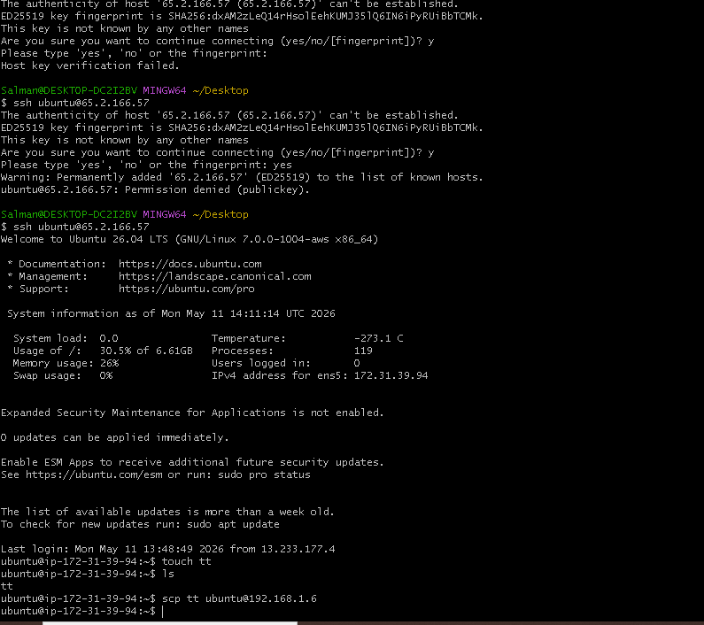

25.Task-Monitor log files using tail or grep
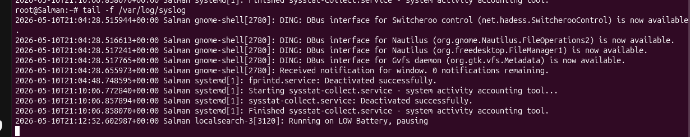

26.Task-Set up a web server (e.g., Apache or Nginx).
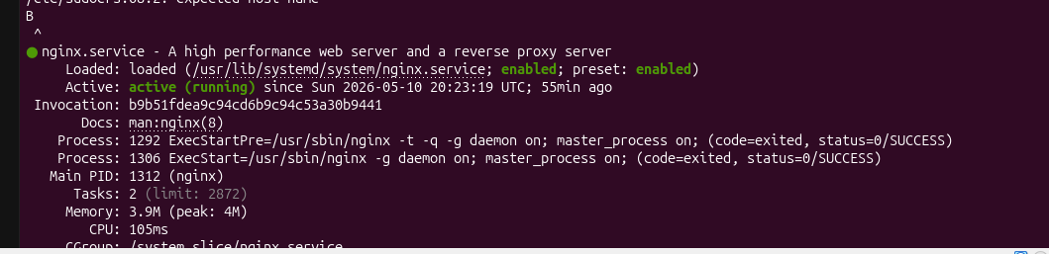
27.Task-Configure and secure a MySQL Databas
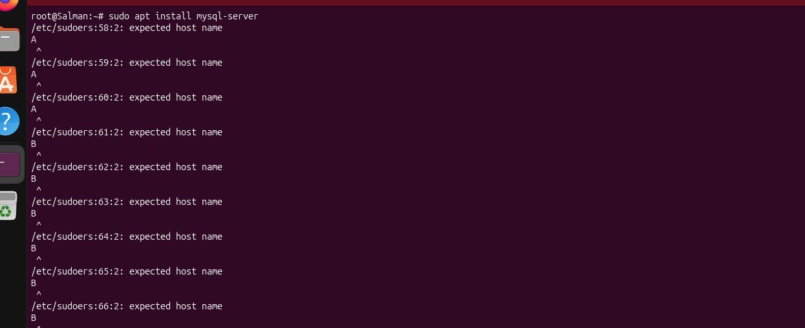

28.Task-Set up a Application Server (e.g.,Apache Tomcat)
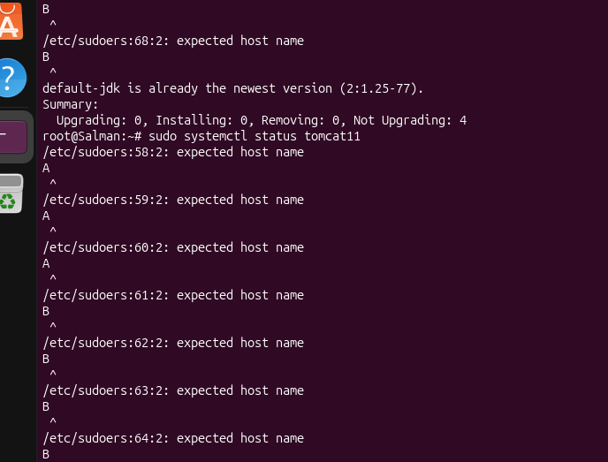
29.Task- create a service file for Apache Tomcat.(Should execute by using systemtctl command)
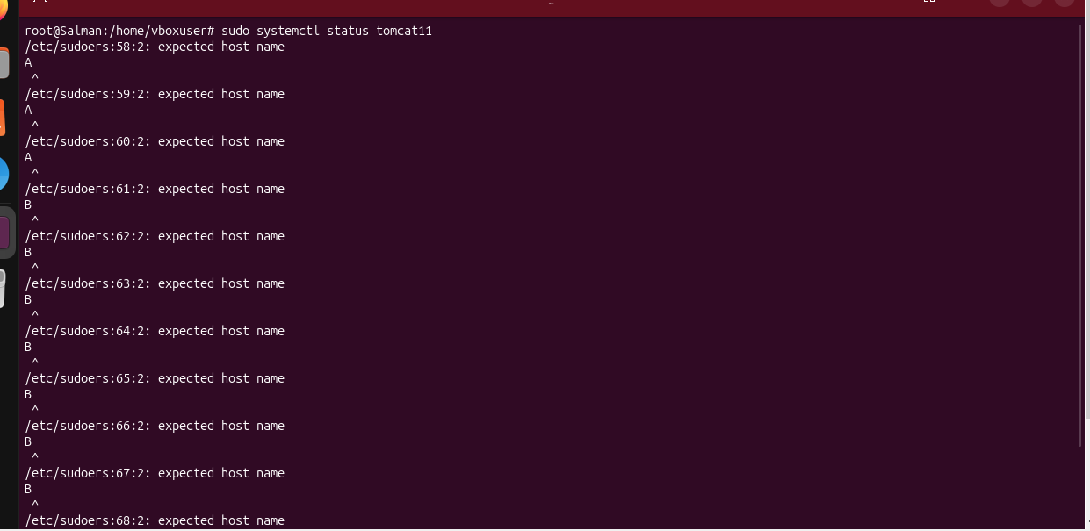

30.Task-Print specific columns from a delimited file
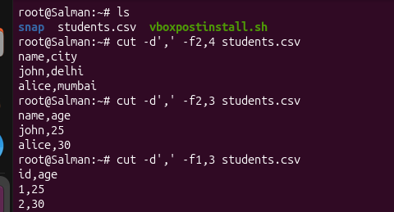

31.Task-Filter and print lines based on a specific pattern or condition
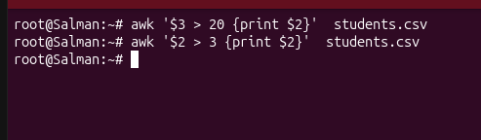
32.Task-Calculate and print the average, sum, or other statistics of a column
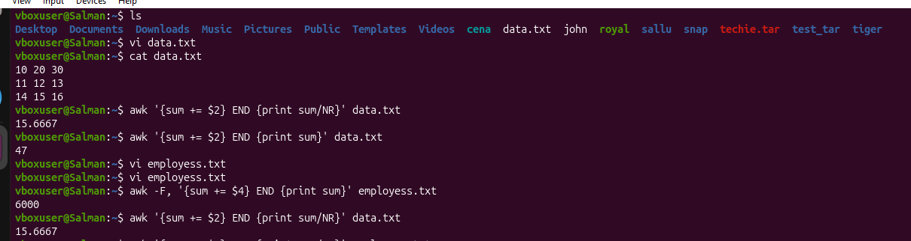

33.Task-Perform string manipulation, such as extracting substrings or changing case.
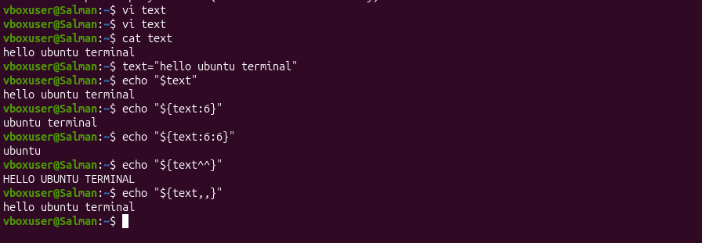

34.Task-Count the occurrences of a specific pattern in a file.


35.Task-Sort lines based on a specific field or column
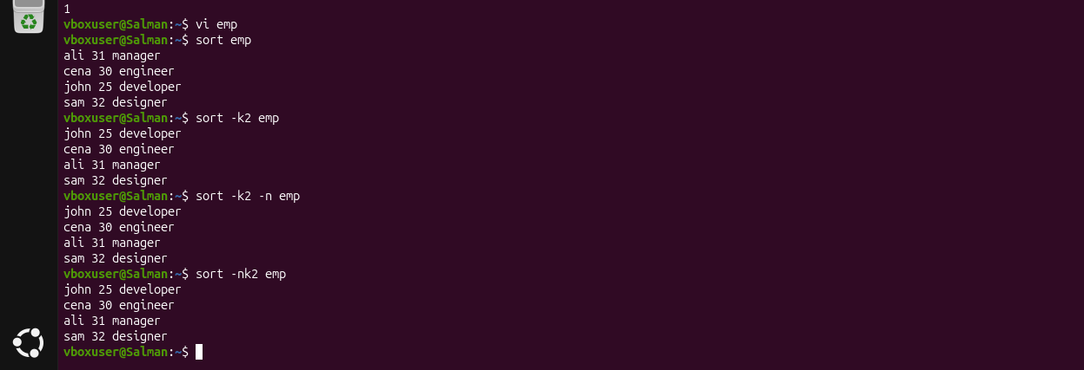
36.Task-Merge multiple files based on a common field or column.
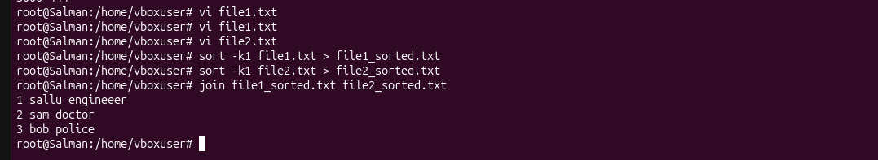

37.Task-Substitute text in a file using search and replace
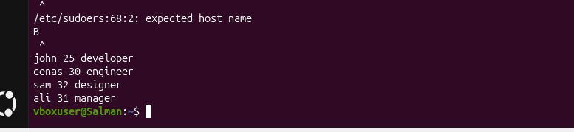

38.Task-Delete specific lines based on a pattern or line number.
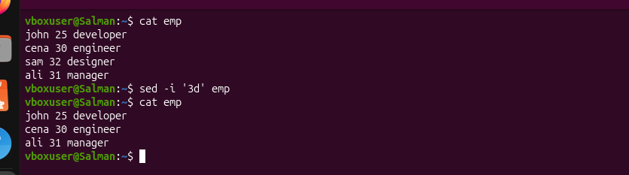

39.Task-Append or insert text before or after a specific pattern or line.
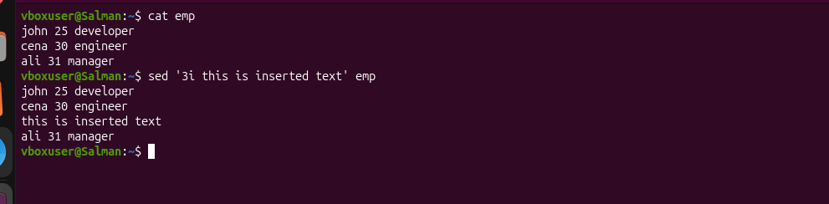

40.Task-Print only specific lines from a file.
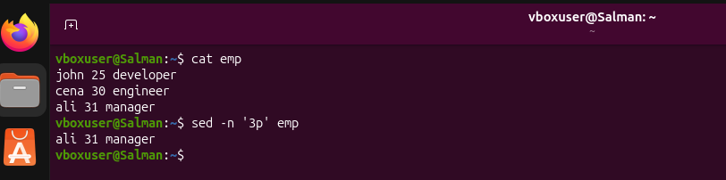

41.Task-Copy file from linux to windows machine
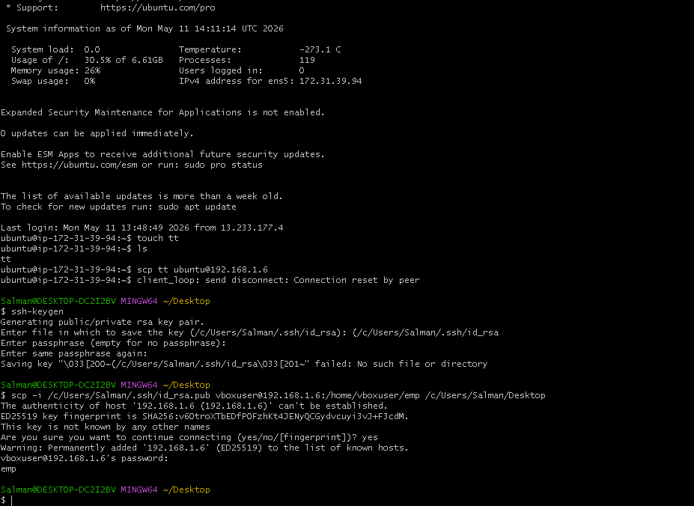

42.Task-5 use cases for AWK and 5 use cases for SED
